I used Copilot to help me refine the logic of my Word Code. It highlighted that there was room to improve the reliability of my proposed solution. One of the issues it raised was the lack of error handling for servo failure. It pointed out that such a fault could leave the pet without food, putting it at risk of starvation. It was clear to me that the concern was for the well-being of the animal, not the logic itself. This was the fifth matter it brought up.

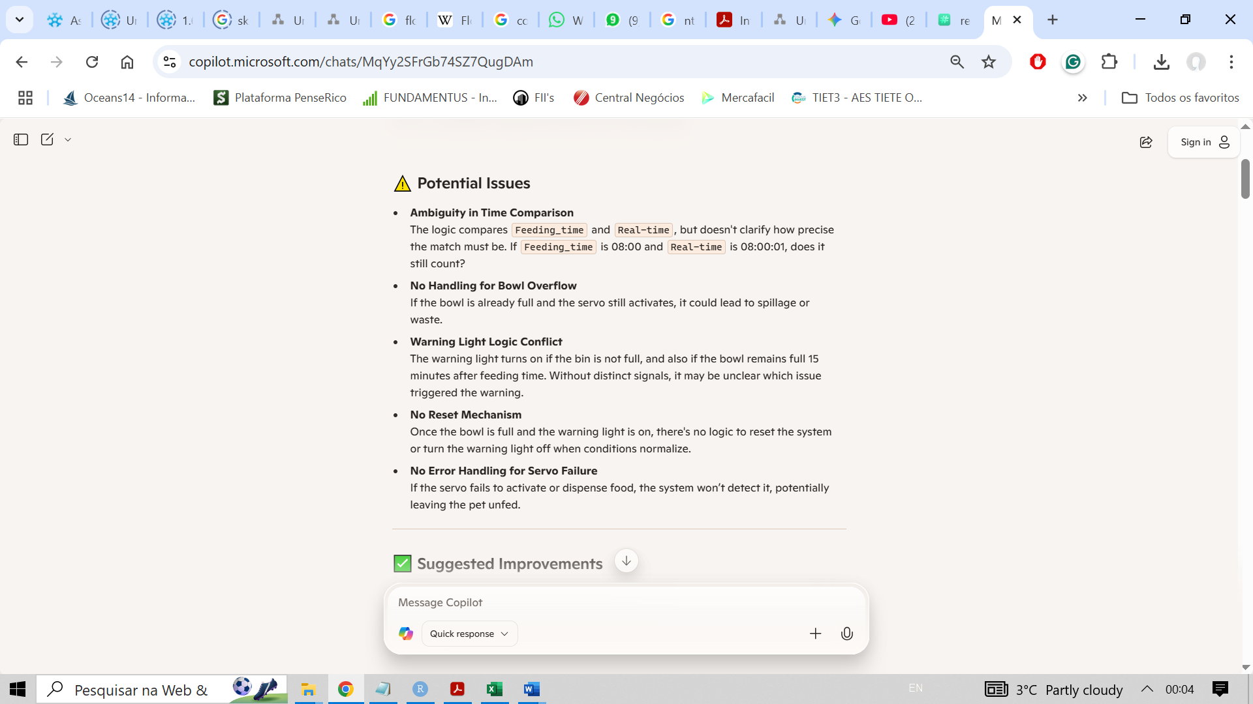

I also prompted Copilot to propose different ways to enhance my flowchart logic by uploading the flowchart file. It returned that there was also room for improvement regarding reliability. One of the reliability issues it raised was "Servo Feedback and Error Handling." This was the third matter it brought up, and it aligned with what Copilot had suggested when refining my previous code. In this case, it only mentioned the technical aspect of the problem, which was to confirm whether or not food was dispensed.

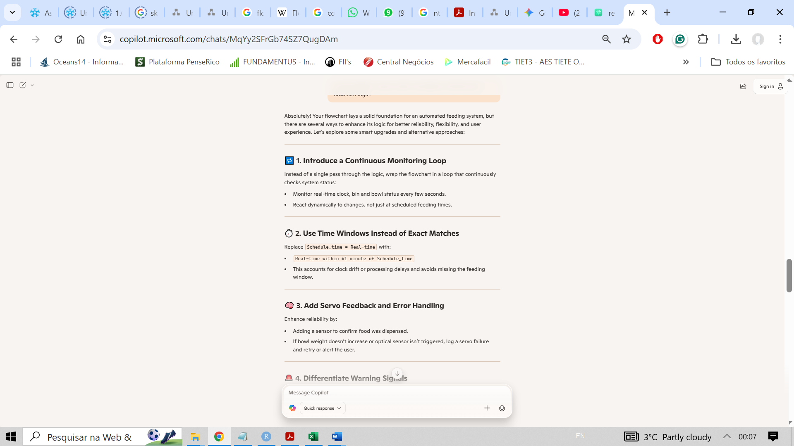

Both questioning were essential gain insights from different perspective that would justify the improvement to the Servo Feedback System (error Handling), specifically, the perspective of the system itself and that of the pet animal relying on it for feeding.

**References**

For this section, Microsoft Copilot AI Agent Integration was used to refine my Word Code and to generate alternative solutions and improvements. The findings were them translated in a short reflection.